

**COMSATS University Islamabad**

**Abbottabad, Pakistan**

**Sabzi Mandi Management System**

***By***

**BASIT IQBAL CIIT/FA2021-BSE-050/ATD**

**FATIMA AFTAB CIIT/FA2021-BSE-088/ATD**

**NOOR-UL-AIN CIIT/FA2020-BCS-089/ATD**

***Supervisor*Dr. Rab Nawaz Jadoon**

***Bachelor of Science in Computer Science (2023-2023)***

**The candidate confirms that the work submitted is their own and appropriate  
 credit has been given where reference has been made to the work of others**.



**EXECUTIVE SUMMARY**

In Abbottabad, Pakistan, the collaboration, and management of data between customers, vendors, and supervisors (AC) in the local Sabzi Mandi (vegetable market) have been a major challenge. The existing system of issuing paper-based lists by the AC to vendors often leads to discrepancies, with vendors deviating from the approved list or making unauthorized changes, resulting in unexpected price inflation. Additionally, the lack of proper data storage and analytics hinder effective decision-making by the government.

To address these issues, we propose the development of a comprehensive Sabzi Mandi database system. This system will facilitate seamless collaboration and ensure transparency among all stakeholders. The system will include an administrative interface for the AC, allowing them to upload and manage the approved daily lists. Customers will have access to view the daily list, ensuring they have up-to-date information. Vendors will be provided with the list directly from the database, preventing unauthorized changes.

By implementing this database system, we aim to eliminate data discrepancies, prevent unauthorized modifications to the list, and enhance transparency in the pricing and availability of fruits and vegetables. The centralized database will enable efficient data storage and retrieval, reducing the chances of data loss and facilitating accurate analytics for informed decision-making by the government.

In conclusion, the Sabzi Mandi database system offers a comprehensive solution to the challenges faced in Abbottabad's Sabzi Mandi. By leveraging technology, stakeholders can collaborate effectively, ensuring adherence to approved lists, combating inflation, and enabling data-driven decision-making. This system will revolutionize the Sabzi Mandi operations, benefiting customers, vendors, and the overall economy.

1. **Introduction**

The Sabzi Mandi Management System is a groundbreaking project designed to address collaboration and data management challenges in Abbottabad's Sabzi Mandi. By implementing a centralized database, the project aims to ensure transparency and prevent unauthorized modifications to the daily lists issued by the supervisors (AC). This digital system will empower customers to access the approved list while providing vendors with a secure and unalterable source of information, ultimately improving efficiency and trust within the Sabzi Mandi.

* 1. **Relevance to Course Modules**

The project is implemented by using the different concepts of database system. It is covering all the concepts of data modeling , including ERD diagram , normalization and creating database Schema.

* 1. **Project Background**

In Abbottabad, Pakistan, the collaboration, and management of data between customers, vendors, and supervisors (AC) in the local Sabzi Mandi (vegetable market) have been a major challenge. The existing system of issuing paper-based lists by the AC to vendors often leads to discrepancies, with vendors deviating from the approved list or making unauthorized changes, resulting in unexpected price inflation. Additionally, the lack of proper data storage and analytics hinder effective decision-making by the government.

To address these issues, we propose the development of a comprehensive Sabzi Mandi database system. This system will facilitate seamless collaboration and ensure transparency among all stakeholders. The system will include an administrative interface for the AC, allowing them to upload and manage the approved daily lists. Customers will have access to view the daily list, ensuring they have up-to-date information. Vendors will be provided with the list directly from the database, preventing unauthorized changes.

* 1. **Literature Review**

There are a lot of projects on internet working on this project. But real-life implementation is not available .

1. **Problem Definition**

In Abbottabad, Pakistan, the collaboration, and management of data between customers, vendors, and supervisors (AC) in the local Sabzi Mandi (vegetable market) have been a major challenge. The existing system of issuing paper-based lists by the AC to vendors often leads to discrepancies, with vendors deviating from the approved list or making unauthorized changes, resulting in unexpected price inflation. Additionally, the lack of proper data storage and analytics hinder effective decision-making by the government.

* 1. **Problem Statement**

To address these issues, we propose the development of a comprehensive Sabzi Mandi database system. This system will facilitate seamless collaboration and ensure transparency among all stakeholders. The system will include an administrative interface for the AC, allowing them to upload and manage the approved daily lists. Customers will have access to view the daily list, ensuring they have up-to-date information. Vendors will be provided with the list directly from the database, preventing unauthorized changes.

* 1. **Proposal**

# Question#1:

Complete ERD

1. With Complete Normalized Relations

# Answer#1:

ERD Diagram of Sabzi Mandi Management System

## Description Of ERD:

**Entities:**

* Admin
* Vendors
* Customers
* Items
* Fruit List
* Vegetable List

**Relations:**

* Admin approves the vegetable List and the fruit List.
* Fruit List and the Vegetable List are given to the vendors.
* Fruit List and the Vegetable List is viewed by the customer.
* Vegetable List have vegetable List Item.
* Fruit List have Fruit List Item.
* Items present in the vegetable list and the fruit list.

**Scenario:**

In Sabazi Mandi Management System, admin is responsible for entering the data to the database and responsible for approving the lists which contain the data present in database. The list view will be generated, and it would only be available for view (i.e read only access) to the customers and vendors who are registered in the database. The customers and vendors are not able to update or change the list.

## ERD Diagram:

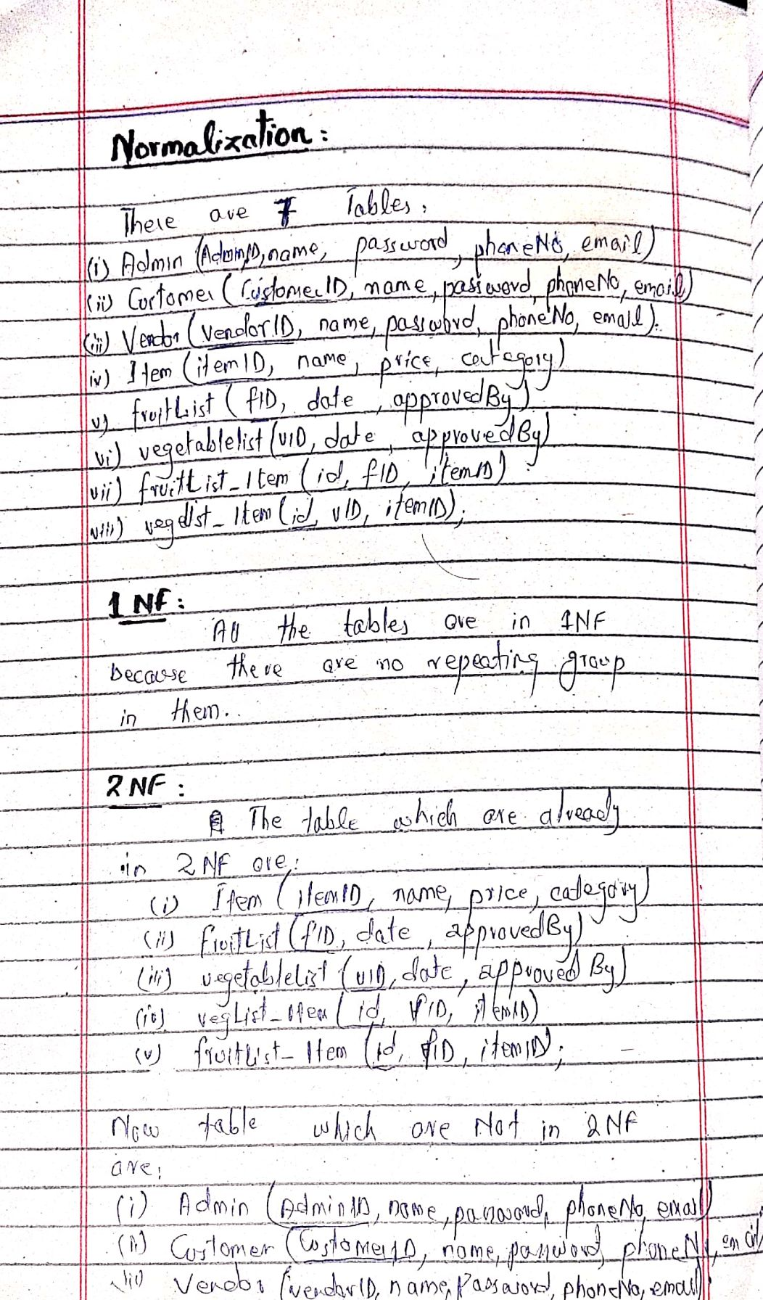NORMALIZATION

